PlaceHolder Navigation System

Test Case

Made by Placeholder©
Weishi Li, Hao Wang, Xinyu Zhang, Junfeng Chen

Table of Contents
Table of Contents 2
Overall Results 3
Test Case: 4
Size 1 Test case 1(Brute Force): 4
Size 1 Test case 1(Nearest Neighbour): 5
Size 1 Test case 2(Brute Force): 6
Size 1 Test case 2(Nearest Neighbour): 7
Size 1 Test case 3(Brute Force): 8
Size 1 Test case 3(Nearest Neighbour): 9
Size 5 Test case 1(Brute Force): 10
Size 5 Test case 1(Nearest Neighbour): 11
Size 5 Test case 2(Brute Force): 12
Size 5 Test case 2(Nearest Neighbour): 13
Size 5 Test case 3(Brute Force): 14
Size 5 Test case 3(Nearest Neighbour): 15
Size 10 Test case 1(Brute Force): 17
Size 10 Test case 1(Nearest Neighbour): 18
Size 10 Test case 2(Nearest Neighbour): 19
Size 10 Test case 3(Nearest Neighbour): 21
Size 15 Test case 1(Nearest Neighbours): 23
Size 15 Test case 2(Nearest Neighbour): 24
Size 15 Test case 3(Nearest Neighbour): 26
Size 20 Test case 1(Nearest Neighbour): 28
Size 20 Test case 2(Nearest Neighbour): 30
Size 20 Test case 3(Nearest Neighbour): 32
Result Analysis 35

Overall Results
*Using default start/end location (0,0)
*Brute force Algorithm doesn’t work well on size 10/15 test cases, due to the enormous amount of combinations. Brute force Algorithm doesn’t work on size20 test cases, due to the enormous amount of combinations.
*Computer specs: win10, 32GB ram, cpu i7-7820hk
 | Run time/s  (Brute force/ Nearest neighbour) | Memory usage/mb  (Brute force/ Nearest neighbour) | Path length  (Brute force/ Nearest neighbour)
Size 1 | 0.009/0.004 | 0.0625/0.0039 | 58/58
Size 1 | 0.010/0.003 | 0.0156/0.003 | 50/50
Size 1 | 0.017/0.003 | 0.0155/0.003 | 54/54
Size 5 | 60.001(time out)/ 0.165 | 0.1289/0.0039 | 66/66
Size 5 | 1.955/ 0.163 | 0.1328/0.0039 | 48/48
Size 5 | 60.008(time out)/ 0.274 | 0.1367/0.0039 | 64/64
Size 10 | 60.011(time out)/  0.328 | 0.2207/0.0039 | 54/54
Size 10 | N/A / 0.545 | N/A / 0.0078 | N/A / 96
Size 10 | N/A / 0.910 | N/A / 0.0078 | N/A / 72
Size 15 | N/A / 1.122 | N/A / 0.004 | N/A / 52
Size 15 | N/A / 1.496 | N/A / 0.0078 | N/A / 98
Size 15 | N/A / 1.461 | N/A / 0.0625 | N/A / 110
Size 20 | N/A / 2.859 | N/A / 0.1133 | N/A / 92
Size 20 | N/A / 2.714 | N/A / 0.0625 | N/A / 92
Size 20 | N/A / 4.465 | N/A / 0.0859 | N/A / 156

Table 1 Summary of test cases

Full details below

Test Case:

Size 1 Test case 1(Brute Force):
ID input order:108335
Final pIckup order: 108335
Path length: 58
Time interval(s): 0.009
Memory usage(mb):0.0625
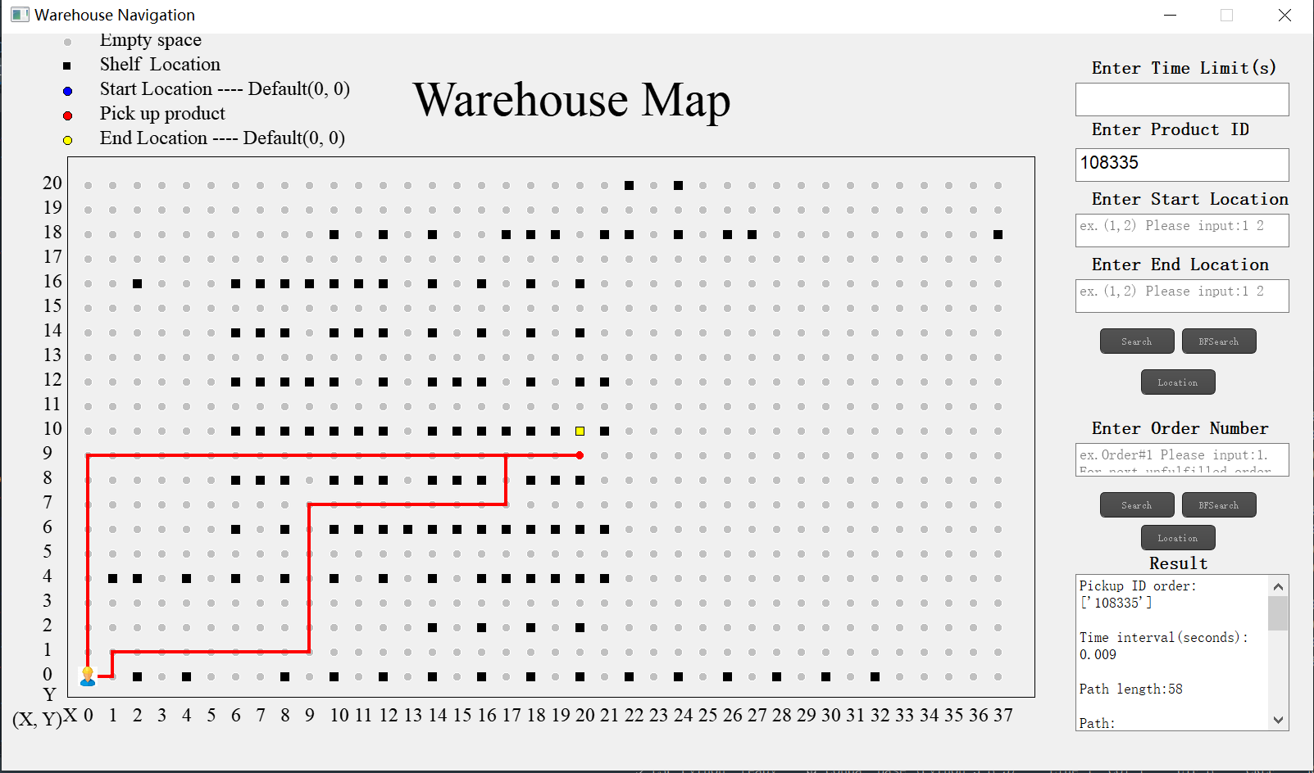
Figure 1 Path of Size 1 Test case 1 by Brute Force

Directions:
From(0, 0)to(1, 0), then go up
From(1, 0)to(1, 1), then go right
From(1, 1)to(9, 1), then go up
From(9, 1)to(9, 7), then go right
From(9, 7)to(17, 7), then go up
From(17, 7)to(17, 9), then go right
From(17, 9)to(20, 9), then stop
Pick up product(108335)
From(20, 9)to(0, 9), then go down
From(0, 9)to(0, 0), then stop

Size 1 Test case 1(Nearest Neighbour):
ID input order:108335
Final pIckup order: 108335
Time interval(s): 0.004
Path length: 58
Memory usage(mb):0.0039
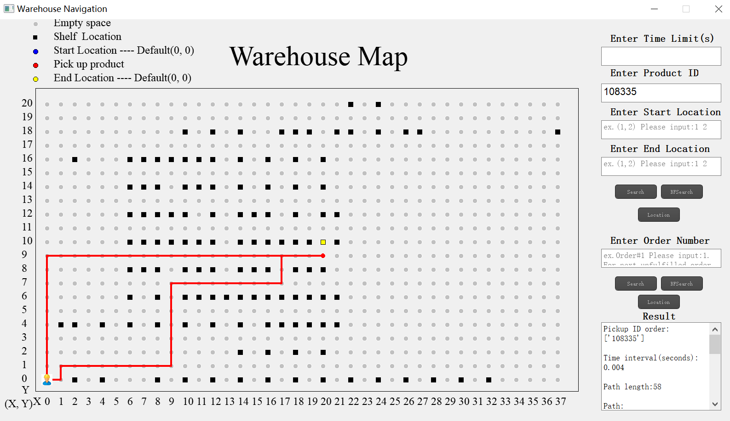
Figure 2 Path of Size 1 Test case 1 by Nearest Neighbours

Directions:
From(0, 0)to(1, 0), then go up
From(1, 0)to(1, 1), then go right
From(1, 1)to(9, 1), then go up
From(9, 1)to(9, 7), then go right
From(9, 7)to(17, 7), then go up
From(17, 7)to(17, 9), then go right
From(17, 9)to(20, 9), then stop
Pick up product(108335)
From(20, 9)to(0, 9), then go down
From(0, 9)to(0, 0), then stop

Size 1 Test case 2(Brute Force):
ID input order:231
Final pIckup order: 231
Path length: 50
Time interval(s): 0.010
Memory usage(mb):0.0156
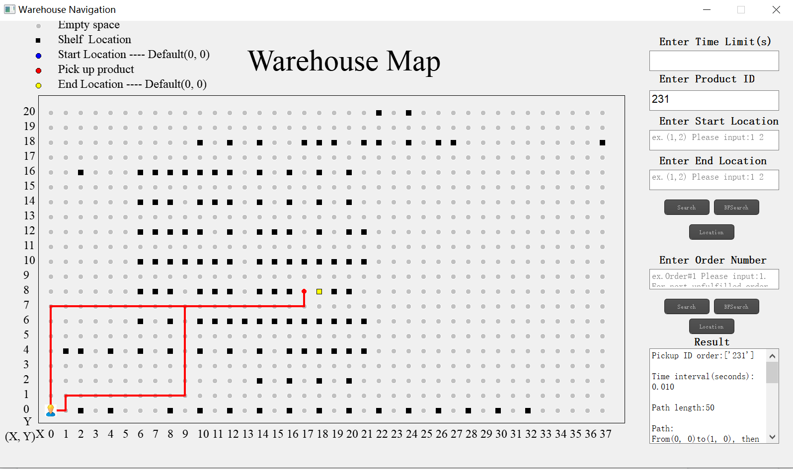
Figure 3 Path of Size 1 Test case 2 by Brute Force

Directions:
Path:
From(0, 0)to(1, 0), then go up
From(1, 0)to(1, 1), then go right
From(1, 1)to(9, 1), then go up
From(9, 1)to(9, 7), then go right
From(9, 7)to(17, 7), then go up
From(17, 7)to(17, 8), then stop
Pick up product(231)
From(17, 8)to(17, 7), then go left
From(17, 7)to(0, 7), then go down
From(0, 7)to(0, 0), then stop

Size 1 Test case 2(Nearest Neighbour):
ID input order:231
Final pIckup order: 231
Time interval(s): 0.003
Path length: 50
Memory usage(mb):0.003
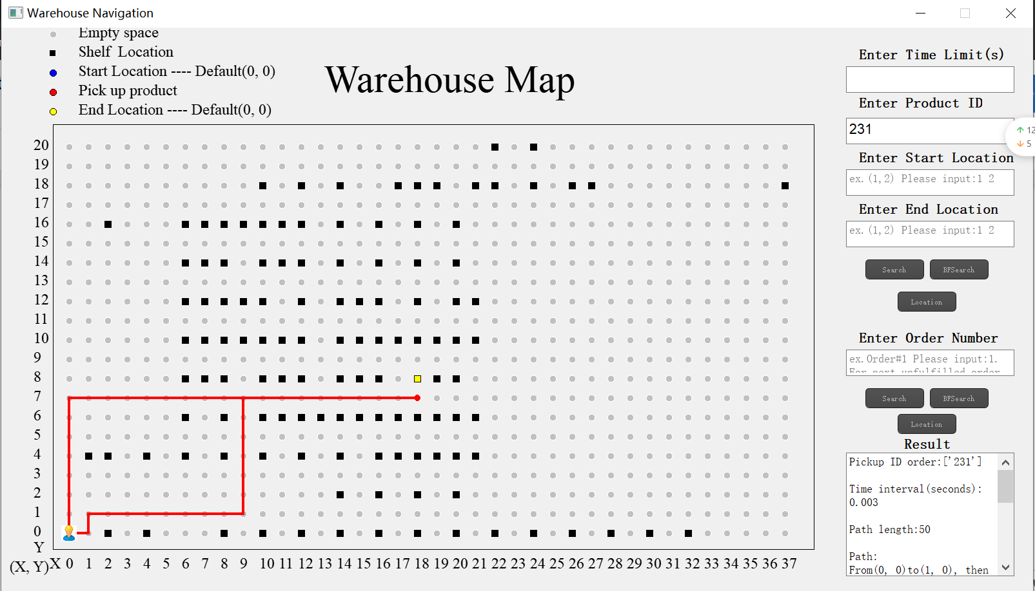
Figure 4 Path of Size 1 Test case 2 by Nearest Neighbours

Directions:
Path:
From(0, 0)to(1, 0), then go up
From(1, 0)to(1, 1), then go right
From(1, 1)to(9, 1), then go up
From(9, 1)to(9, 7), then go right
From(9, 7)to(18, 7), then stop
Pick up product(231)
From(18, 7)to(0, 7), then go down
From(0, 7)to(0, 0), then stop

Size 1 Test case 3(Brute Force):
ID input order:8777
Final pIckup order: 8777
Path length: 54
Time interval(s): 0.017
Memory usage(mb):0.0155
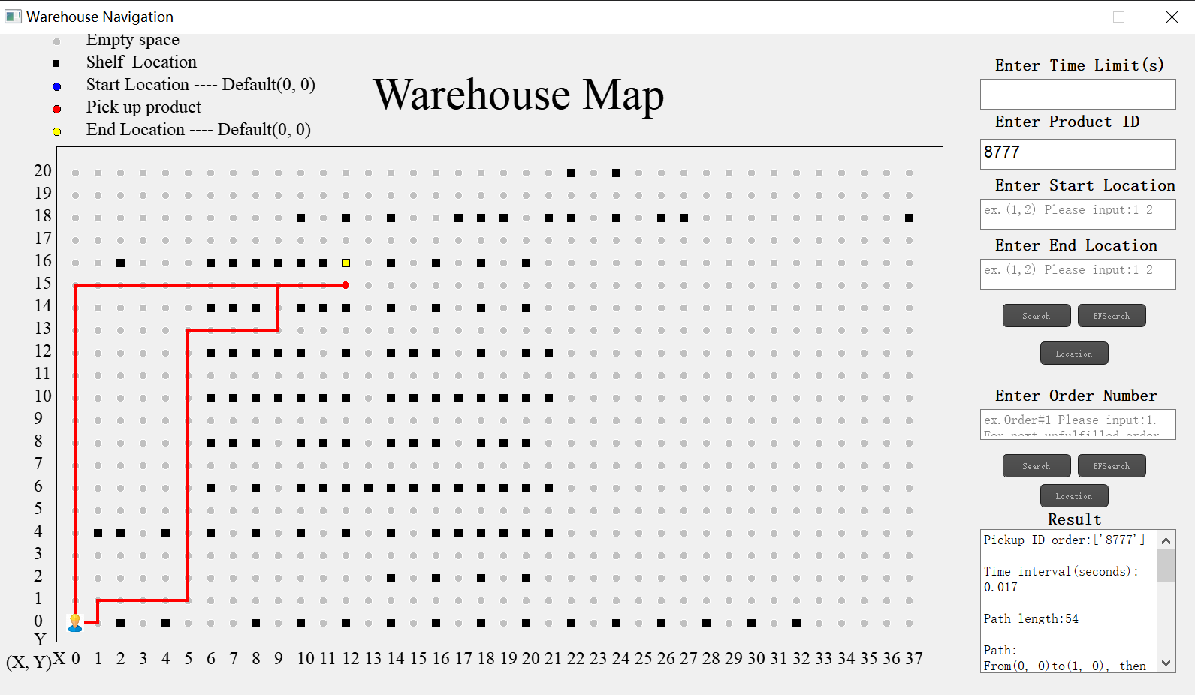
Figure 5 Path of Size 1 Test case 3 by Brute Force

Directions:
Path:
From(0, 0)to(1, 0), then go up
From(1, 0)to(1, 1), then go right
From(1, 1)to(5, 1), then go up
From(5, 1)to(5, 13), then go right
From(5, 13)to(9, 13), then go up
From(9, 13)to(9, 15), then go right
From(9, 15)to(12, 15), then stop
Pick up product(8777)
From(12, 15)to(0, 15), then go down
From(0, 15)to(0, 0), then stop

Size 1 Test case 3(Nearest Neighbour):
ID input order:8777
Final pIckup order: 8777
Time interval(s): 0.003
Path length: 54
Memory usage(mb):0.003

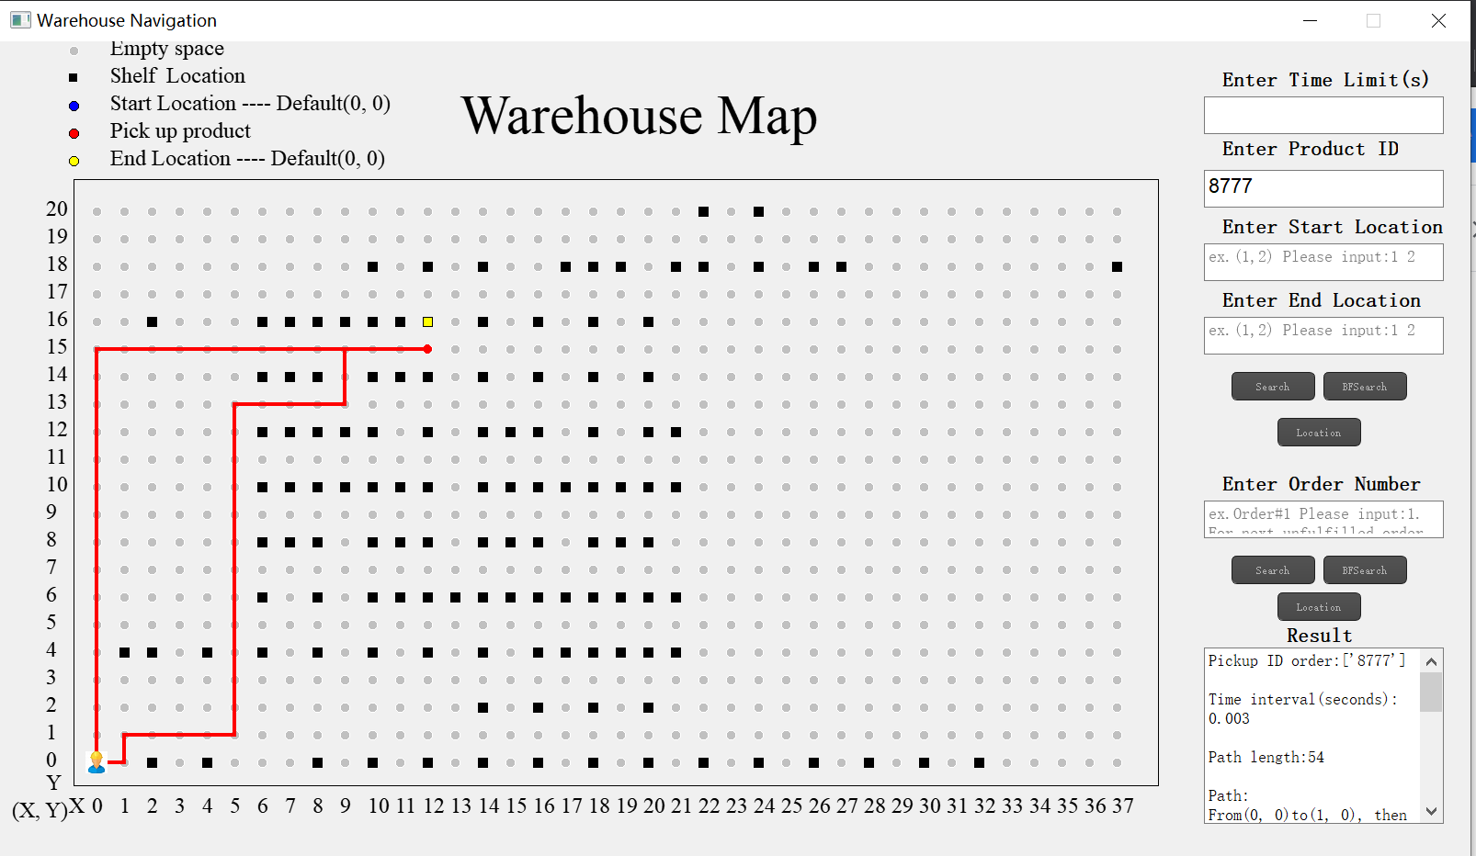
Figure 6 Path of Size 1 Test case 3 by Nearest Neighbours

Directions:
Path:
From(0, 0)to(1, 0), then go up
From(1, 0)to(1, 1), then go right
From(1, 1)to(5, 1), then go up
From(5, 1)to(5, 13), then go right
From(5, 13)to(9, 13), then go up
From(9, 13)to(9, 15), then go right
From(9, 15)to(12, 15), then stop
Pick up product(8777)
From(12, 15)to(0, 15), then go down
From(0, 15)to(0, 0), then stop

Size 5 Test case 1(Brute Force):
ID input order:108335 391825 340367 286457 661741
Final pIckup order: 340367 661741 286457 108335 391825
Path length: 66
Time interval(s): 60.001(time out)
Memory usage(mb):0.1289
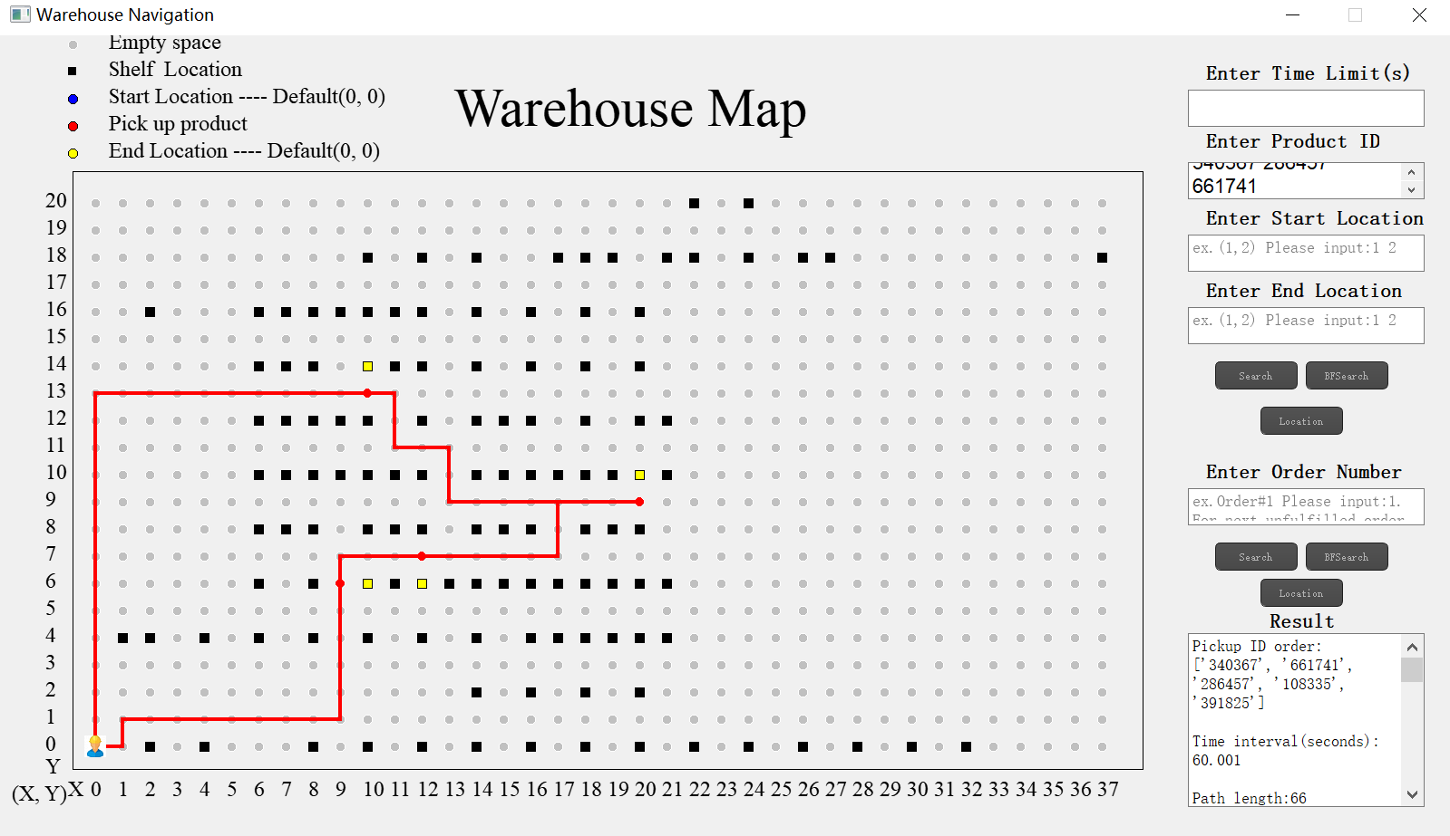
Figure 7 Path of Size 5 Test case 1 by Brute Force

Directions:
From(0, 0)to(1, 0), then go up
From(1, 0)to(1, 1), then go right
From(1, 1)to(9, 1), then go up
From(9, 1)to(9, 6), then stop
Pick up product(340367)
Pick up product(661741)
From(9, 6)to(9, 7), then go right
From(9, 7)to(12, 7), then stop
Pick up product(286457)
From(12, 7)to(17, 7), then go up
From(17, 7)to(17, 9), then go right
From(17, 9)to(20, 9), then stop
Pick up product(108335)
From(20, 9)to(13, 9), then go up
From(13, 9)to(13, 11), then go left
From(13, 11)to(11, 11), then go up
From(11, 11)to(11, 13), then go left
From(11, 13)to(10, 13), then stop
Pick up product(391825)
From(10, 13)to(0, 13), then go down
From(0, 13)to(0, 0), then stop

Size 5 Test case 1(Nearest Neighbour):
ID input order:108335 391825 340367 286457 661741
Final pIckup order: 340367 661741 286457 108335 391825
Time interval(s): 0.165
Path length: 66
Memory usage(mb):0.0039
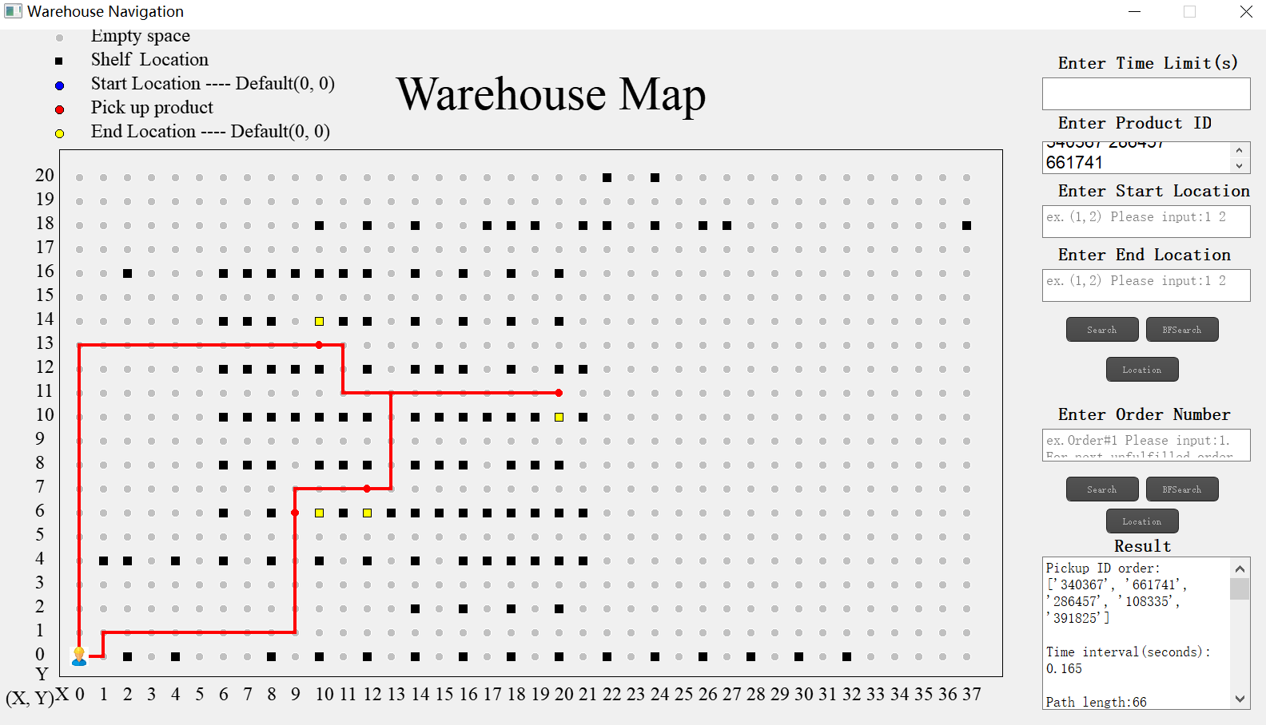
Figure 8 Path of Size 5 Test case 1 by Nearest Neighbours

Directions:
From(0, 0)to(1, 0), then go up
From(1, 0)to(1, 1), then go right
From(1, 1)to(9, 1), then go up
From(9, 1)to(9, 7), then go right
From(9, 7)to(10, 7), then stop
Pick up product(340367)
Pick up product(661741)
From(10, 7)to(12, 7), then stop
Pick up product(286457)
From(12, 7)to(13, 7), then go up
From(13, 7)to(13, 11), then go right
From(13, 11)to(20, 11), then stop
Pick up product(108335)
From(20, 11)to(11, 11), then go up
From(11, 11)to(11, 13), then go left
From(11, 13)to(10, 13), then stop
Pick up product(391825)
From(10, 13)to(0, 13), then go down
From(0, 13)to(0, 0), then stop

Size 5 Test case 2(Brute Force):
ID input order:352109 397889 386850 380489 287261
Final pIckup order: 287261 380489 352109 397889 386850
Path length: 48
Time interval(s): 1.955
Memory usage(mb):0.1328
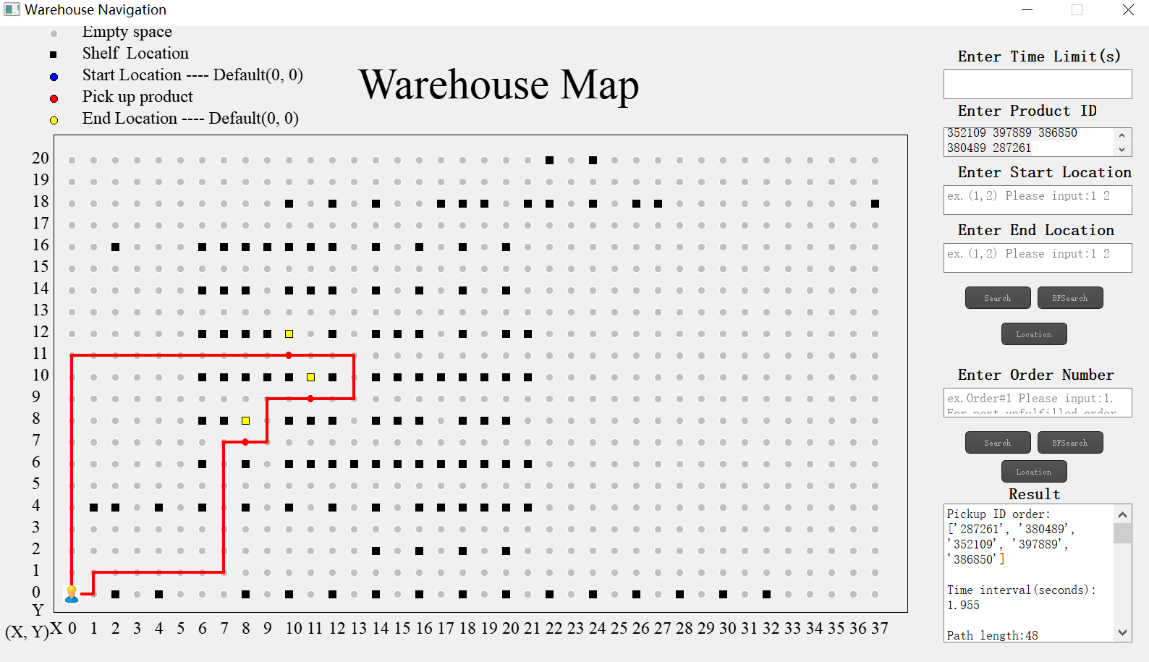
Figure 9 Path of Size 5 Test case 2 by Brute Force

Directions:
From(0, 0)to(1, 0), then go up
From(1, 0)to(1, 1), then go right
From(1, 1)to(9, 1), then go up
From(9, 1)to(9, 8), then stop
Pick up product(287261)
From(9, 8)to(9, 9), then go right
From(9, 9)to(13, 9), then go up
From(13, 9)to(13, 11), then go left
From(13, 11)to(11, 11), then stop
Pick up product(380489)
From(11, 11)to(10, 11), then stop
Pick up product(352109)
Pick up product(397889)
Pick up product(386850)
From(10, 11)to(0, 11), then go down
From(0, 11)to(0, 0), then stop

Size 5 Test case 2(Nearest Neighbour):
ID input order:352109 397889 386850 380489 287261
Final pIckup order: 287261 380489 352109 397889 386850
Time interval(s): 0.066
Path length: 48
Memory usage(mb):0.0039
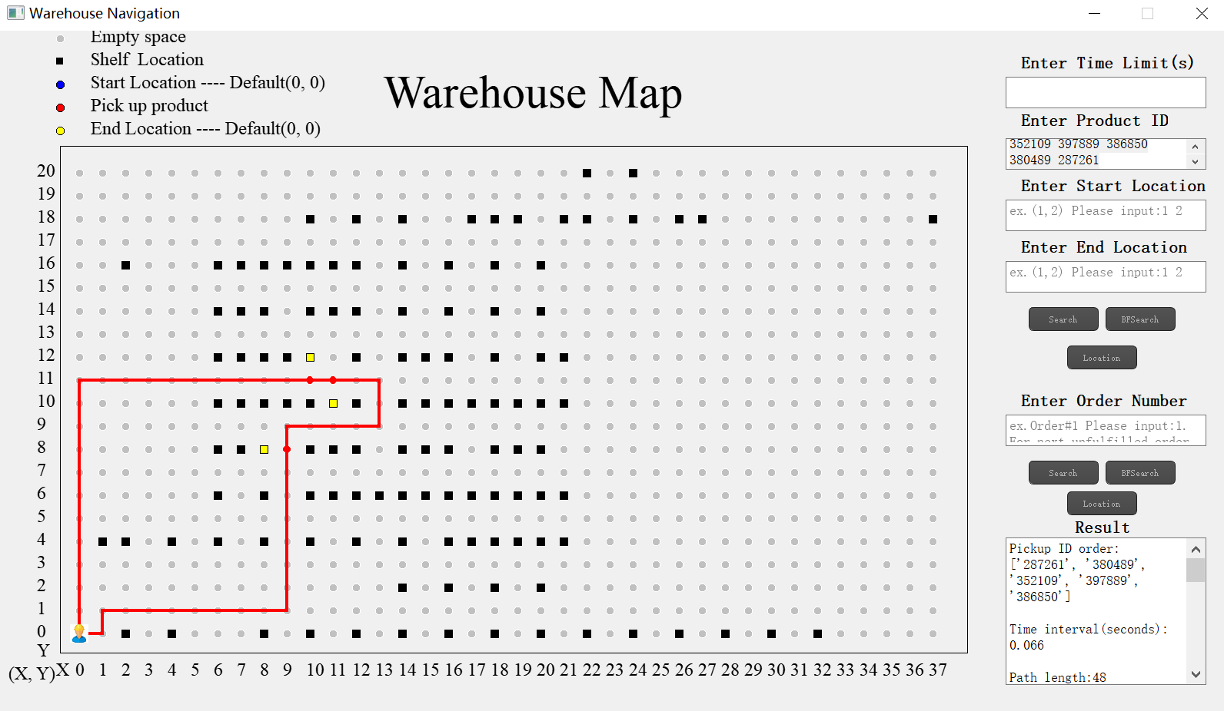
Figure 10 Path of Size 5 Test case 2 by Nearest Neighbours

Directions:
From(0, 0)to(1, 0), then go up
From(1, 0)to(1, 1), then go right
From(1, 1)to(9, 1), then go up
From(9, 1)to(9, 8), then stop
Pick up product(287261)
From(9, 8)to(9, 9), then go right
From(9, 9)to(13, 9), then go up
From(13, 9)to(13, 11), then go left
From(13, 11)to(11, 11), then stop
Pick up product(380489)
From(11, 11)to(10, 11), then stop
Pick up product(352109)
Pick up product(397889)
Pick up product(386850)
From(10, 11)to(0, 11), then go down
From(0, 11)to(0, 0), then stop

Size 5 Test case 3(Brute Force):
ID input order:1365 915008 395667 2353999 2355128
Final pIckup order: 1365 395667 2353999 2355128 915008
Path length: 64
Time interval(s): 60.008(time out)
Memory usage(mb):0.136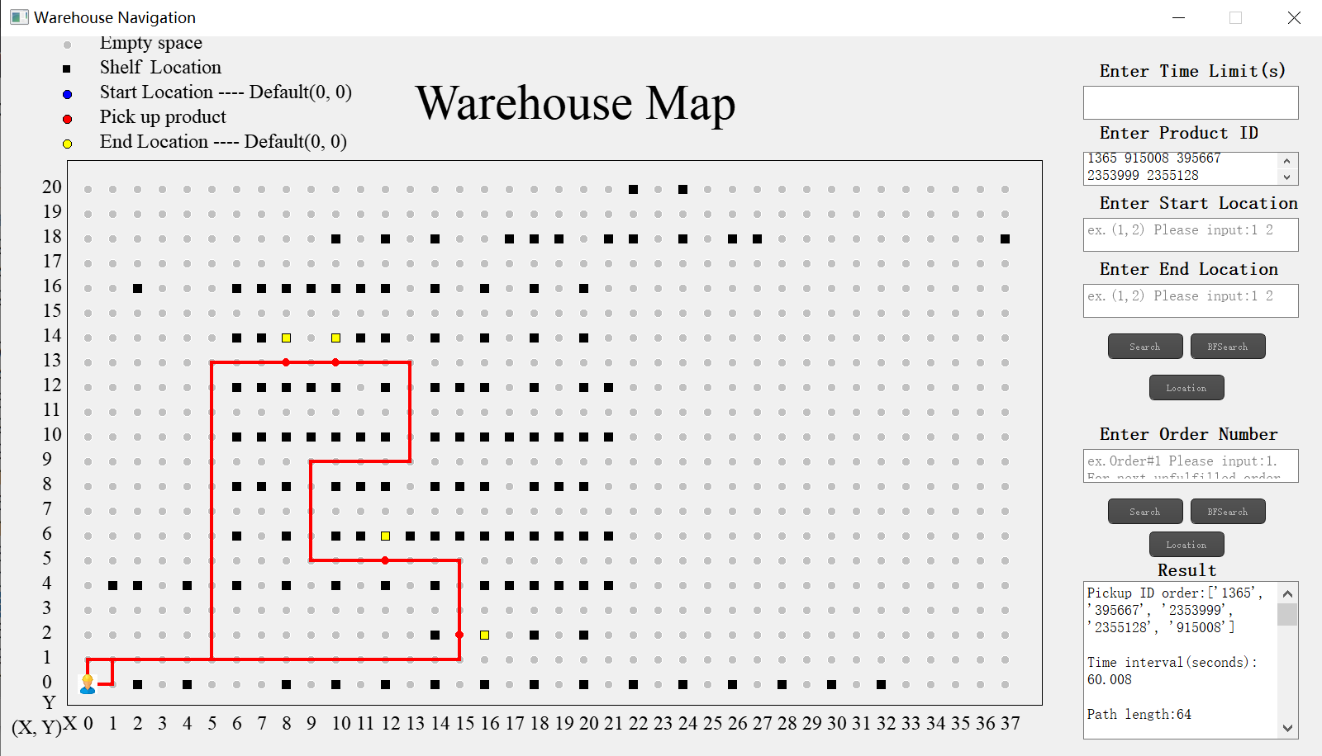
Figure 11 Path of Size 5 Test case 3 by Brute Force

Directions:
From(0, 0)to(1, 0), then go up
From(1, 0)to(1, 1), then go right
From(1, 1)to(5, 1), then go up
From(5, 1)to(5, 13), then go right
From(5, 13)to(8, 13), then stop
Pick up product(1365)
From(8, 13)to(10, 13), then stop
Pick up product(395667)
From(10, 13)to(13, 13), then go down
From(13, 13)to(13, 9), then go left
From(13, 9)to(9, 9), then go down
From(9, 9)to(9, 5), then go right
From(9, 5)to(12, 5), then stop
Pick up product(2353999)
Pick up product(2355128)
From(12, 5)to(15, 5), then go down
From(15, 5)to(15, 2), then stop
Pick up product(915008)
From(15, 2)to(15, 1), then go left
From(15, 1)to(0, 1), then go down
From(0, 1)to(0, 0), then stop

Size 5 Test case 3(Nearest Neighbour):
ID input order:1365 915008 395667 2353999 2355128
Final pIckup order: 915008 2353999 2355128 395667 1365
Time interval(s): 0.274
Path length: 54
Memory usage(mb):0.0039
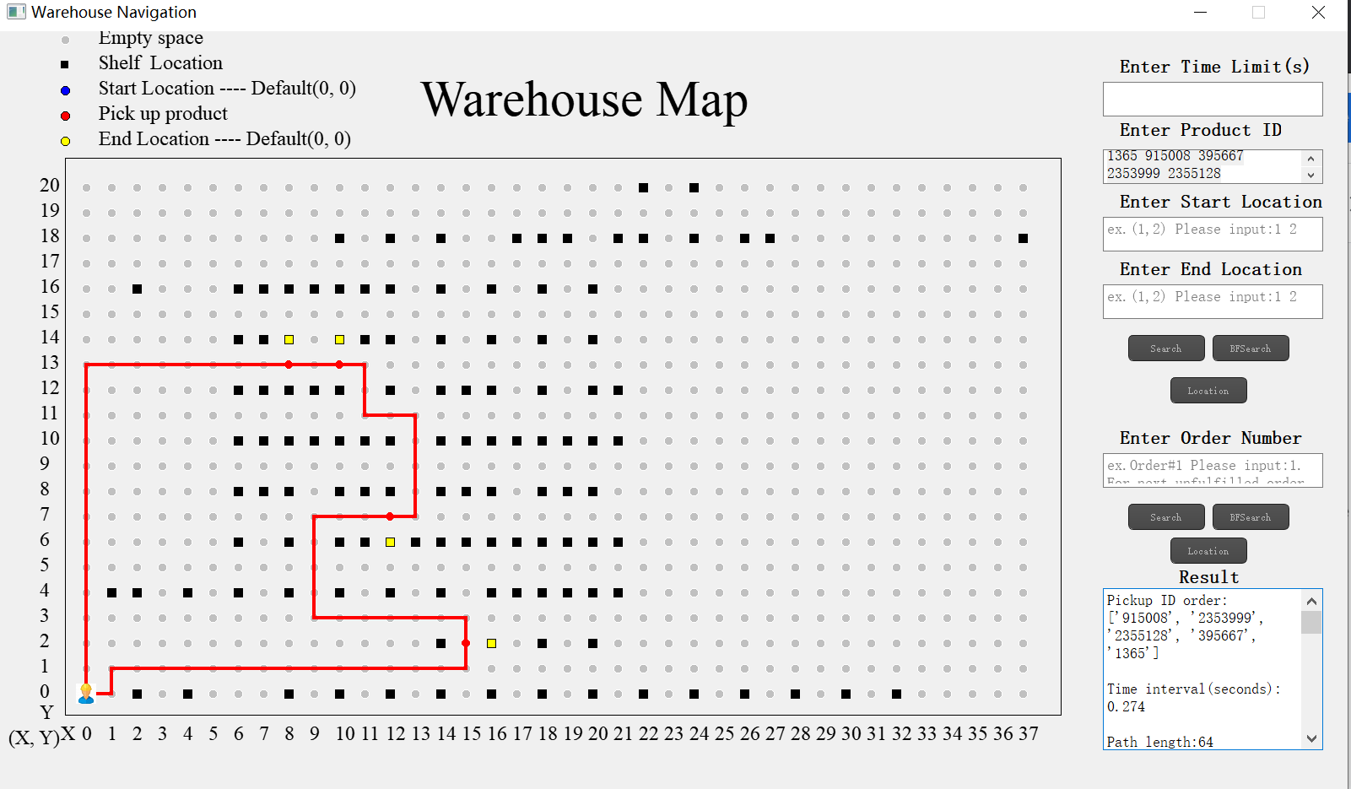
Figure 12 Path of Size 5 Test case 3 by Nearest Neighbours

Directions:
From(0, 0)to(1, 0), then go up
From(1, 0)to(1, 1), then go right
From(1, 1)to(15, 1), then go up
From(15, 1)to(15, 2), then stop
Pick up product(915008)
From(15, 2)to(15, 3), then go left
From(15, 3)to(9, 3), then go up
From(9, 3)to(9, 7), then go right
From(9, 7)to(12, 7), then stop
Pick up product(2353999)
Pick up product(2355128)
From(12, 7)to(13, 7), then go up
From(13, 7)to(13, 11), then go left
From(13, 11)to(11, 11), then go up
From(11, 11)to(11, 13), then go left
From(11, 13)to(10, 13), then stop
Pick up product(395667)
From(10, 13)to(8, 13), then stop
Pick up product(1365)
From(8, 13)to(0, 13), then go down
From(0, 13)to(0, 0), then stop

Size 10 Test case 1(Brute Force):
ID input order:281610 342706 111873 198029 366109 287261 76283 254489 258540 286457
Final pIckup order: 342706 111873 287261 281610 366109 76283 198029 286457 258540 254489
Path length: 54
Time interval(s): 60.013 (time out)
Memory usage(mb): 0.2207
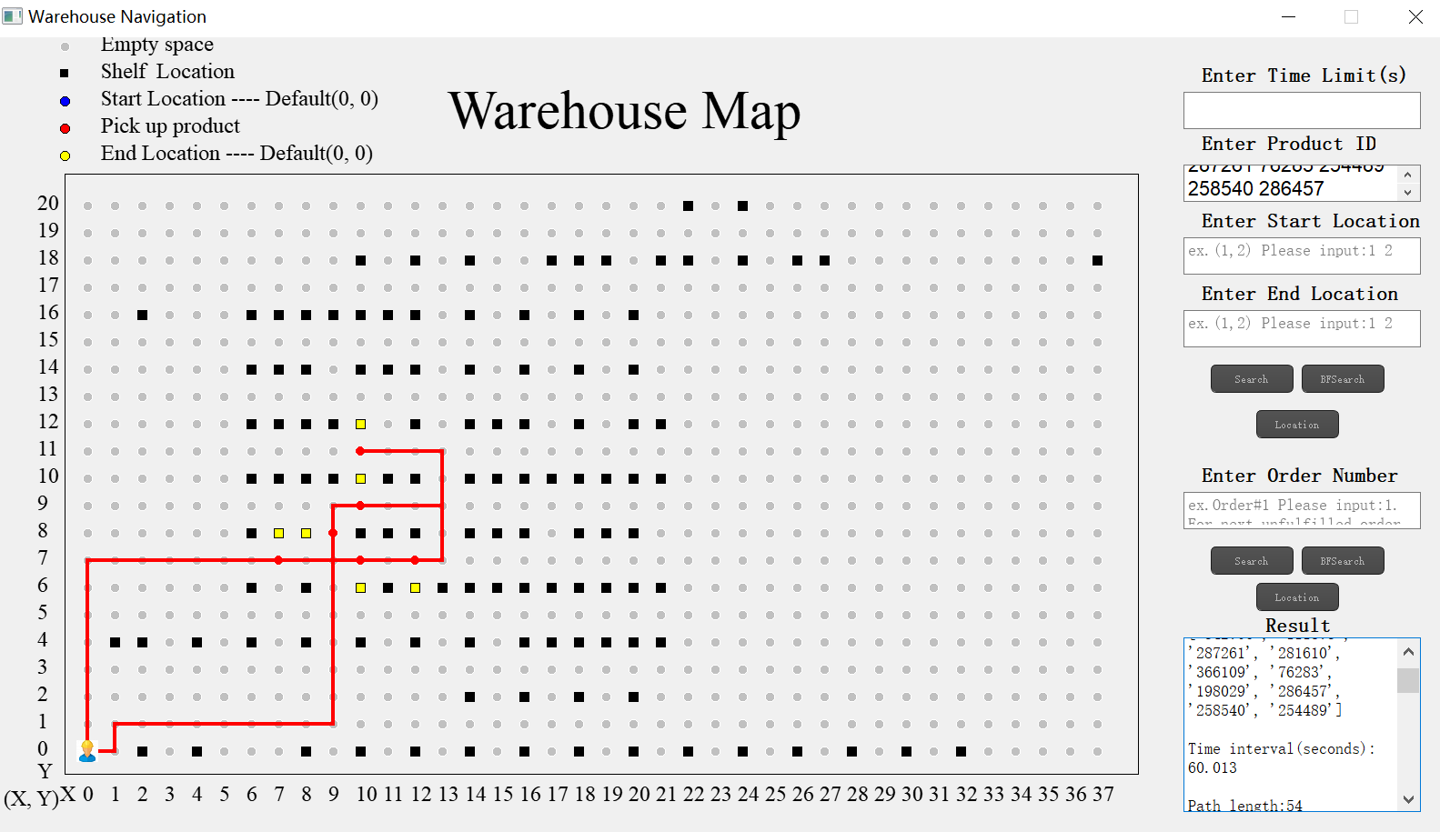
Figure 13 Path of Size 10 Test case 1 by Brute Force

Directions:
Path:
From(0, 0)to(1, 0), then go up
From(1, 0)to(1, 1), then go right
From(1, 1)to(9, 1), then go up
From(9, 1)to(9, 8), then stop
Pick up product(342706)
Pick up product(111873)
Pick up product(287261)
From(9, 8)to(9, 9), then go right
From(9, 9)to(10, 9), then stop
Pick up product(281610)
Pick up product(366109)
Pick up product(76283)
From(10, 9)to(13, 9), then go up
From(13, 9)to(13, 11), then go left
From(13, 11)to(10, 11), then stop
Pick up product(198029)
From(10, 11)to(13, 11), then go down
From(13, 11)to(13, 7), then go left
From(13, 7)to(12, 7), then stop
Pick up product(286457)
From(12, 7)to(10, 7), then stop
Pick up product(258540)
From(10, 7)to(7, 7), then stop
Pick up product(254489)
From(7, 7)to(0, 7), then go down
From(0, 7)to(0, 0), then stop

Size 10 Test case 1(Nearest Neighbour):
ID input order:281610 342706 111873 198029 366109 287261 76283 254489 258540 286457
Final pIckup order:254489 342706 111873 287261 281610 366109 76283 198029 286457 258540
Time interval(s): 0.328
Path length: 54
Memory usage(mb): 0.039
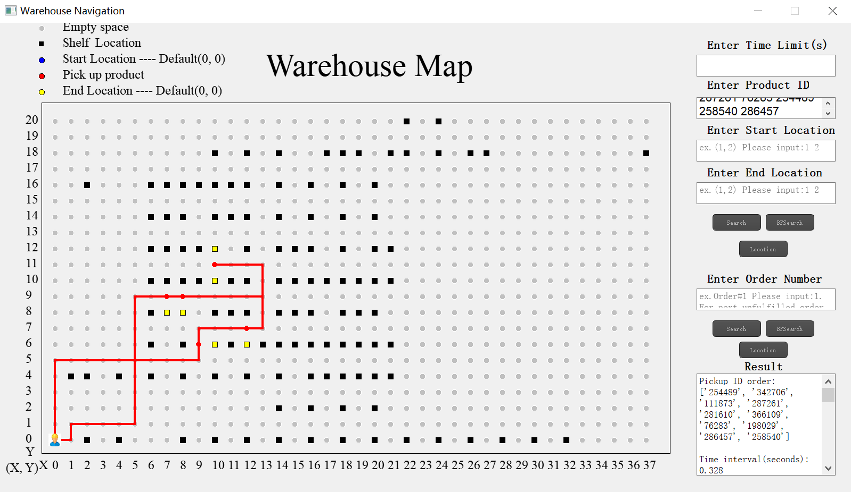
Figure 14 Path of Size 10 Test case 1 by Nearest Neighbours
Directions:
Path:
From(0, 0)to(1, 0), then go up
From(1, 0)to(1, 1), then go right
From(1, 1)to(5, 1), then go up
From(5, 1)to(5, 9), then go right
From(5, 9)to(7, 9), then stop
Pick up product(254489)
From(7, 9)to(8, 9), then stop
Pick up product(342706)
Pick up product(111873)
Pick up product(287261)
From(8, 9)to(13, 9), then go up
From(13, 9)to(13, 11), then go left
From(13, 11)to(10, 11), then stop
Pick up product(281610)
Pick up product(366109)
Pick up product(76283)
Pick up product(198029)
From(10, 11)to(13, 11), then go down
From(13, 11)to(13, 7), then go left
From(13, 7)to(12, 7), then stop
Pick up product(286457)
From(12, 7)to(9, 7), then go down
From(9, 7)to(9, 5), then go right
From(9, 5)to(10, 5), then stop
Pick up product(258540)
From(10, 5)to(0, 5), then go down
From(0, 5)to(0, 0), then stop

Size 10 Test case 2(Nearest Neighbour):
ID input order:359 364 444 485 515 517 571 610 623 633
Final pIckup order: 515 517 610 364 623 359 633 571 444 485
Time interval(s): 0.545
Path length: 96
Memory usage(mb):0.0078
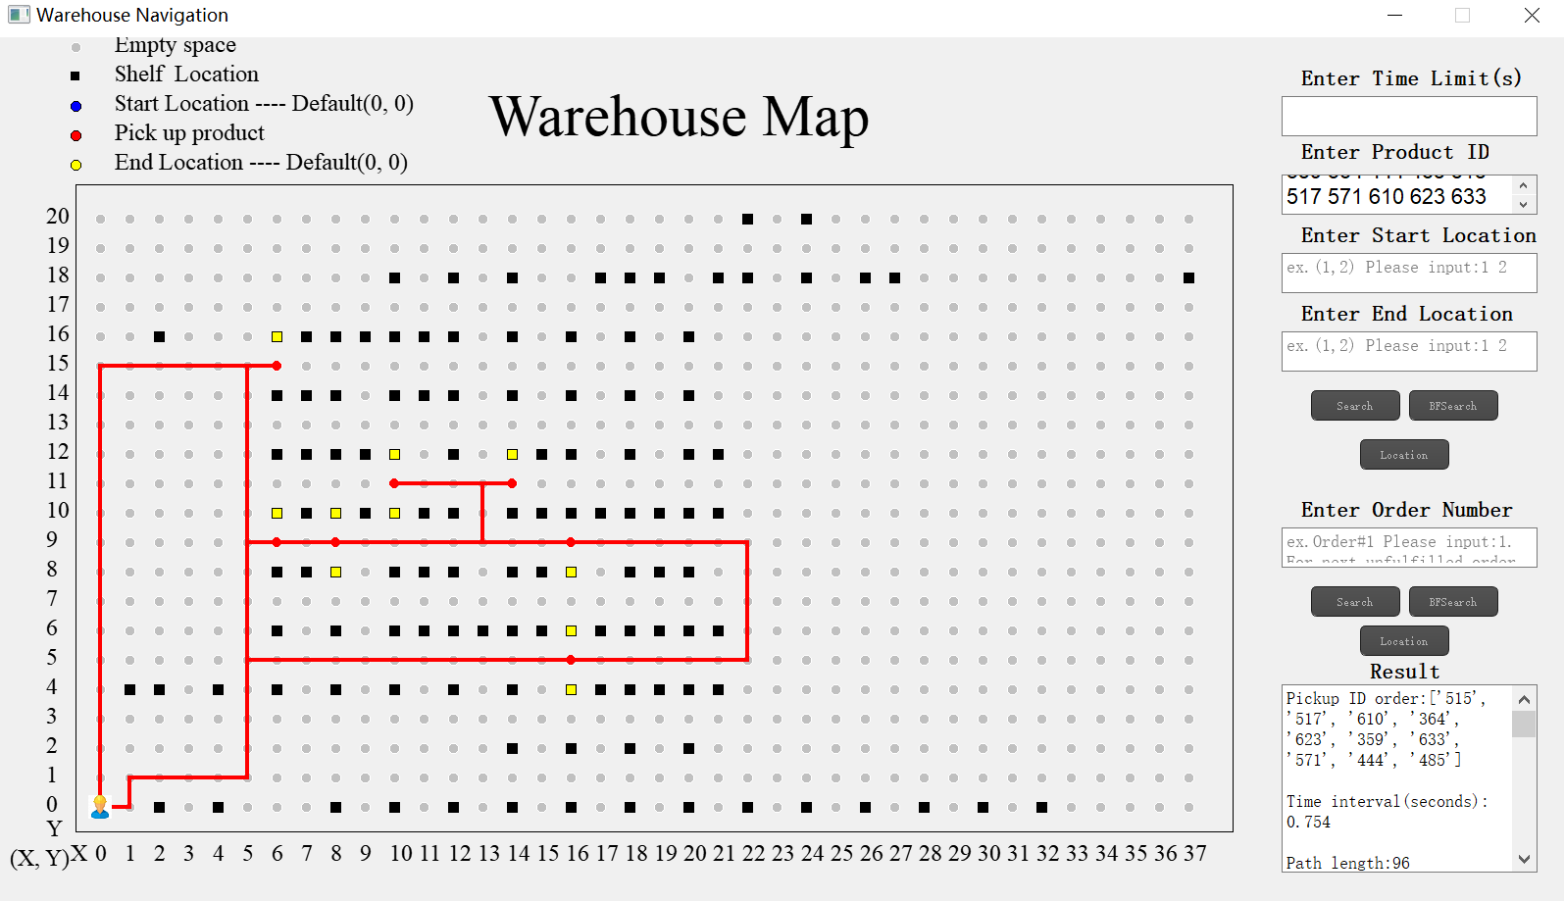
Figure 15 Path of Size 10 Test case 2 by Nearest Neighbours

Directions:

From(0, 0)to(1, 0), then go up
From(1, 0)to(1, 1), then go right
From(1, 1)to(5, 1), then go up
From(5, 1)to(5, 9), then go right
From(5, 9)to(6, 9), then stop
Pick up product(515)
From(6, 9)to(8, 9), then stop
Pick up product(517)
Pick up product(610)
From(8, 9)to(13, 9), then go up
From(13, 9)to(13, 11), then go left
From(13, 11)to(10, 11), then stop
Pick up product(364)
Pick up product(623)
From(10, 11)to(14, 11), then stop
Pick up product(359)
From(14, 11)to(13, 11), then go down
From(13, 11)to(13, 9), then go right
From(13, 9)to(16, 9), then stop
Pick up product(633)
From(16, 9)to(22, 9), then go down
From(22, 9)to(22, 5), then go left
From(22, 5)to(16, 5), then stop
Pick up product(571)
Pick up product(444)
From(16, 5)to(5, 5), then go up
From(5, 5)to(5, 15), then go right
From(5, 15)to(6, 15), then stop
Pick up product(485)
From(6, 15)to(0, 15), then go down
From(0, 15)to(0, 0), then stop

Size 10 Test case 3(Nearest Neighbour):
ID input order:176484 245818 195946 272457 354111 103926 106685 260033 306104 397673
Final pIckup order: 176484 272457 397673 306104 103926 106685 260033 354111 195946 245818
Time interval(s): 0.910
Path length: 72
Memory usage(mb): 0.0078
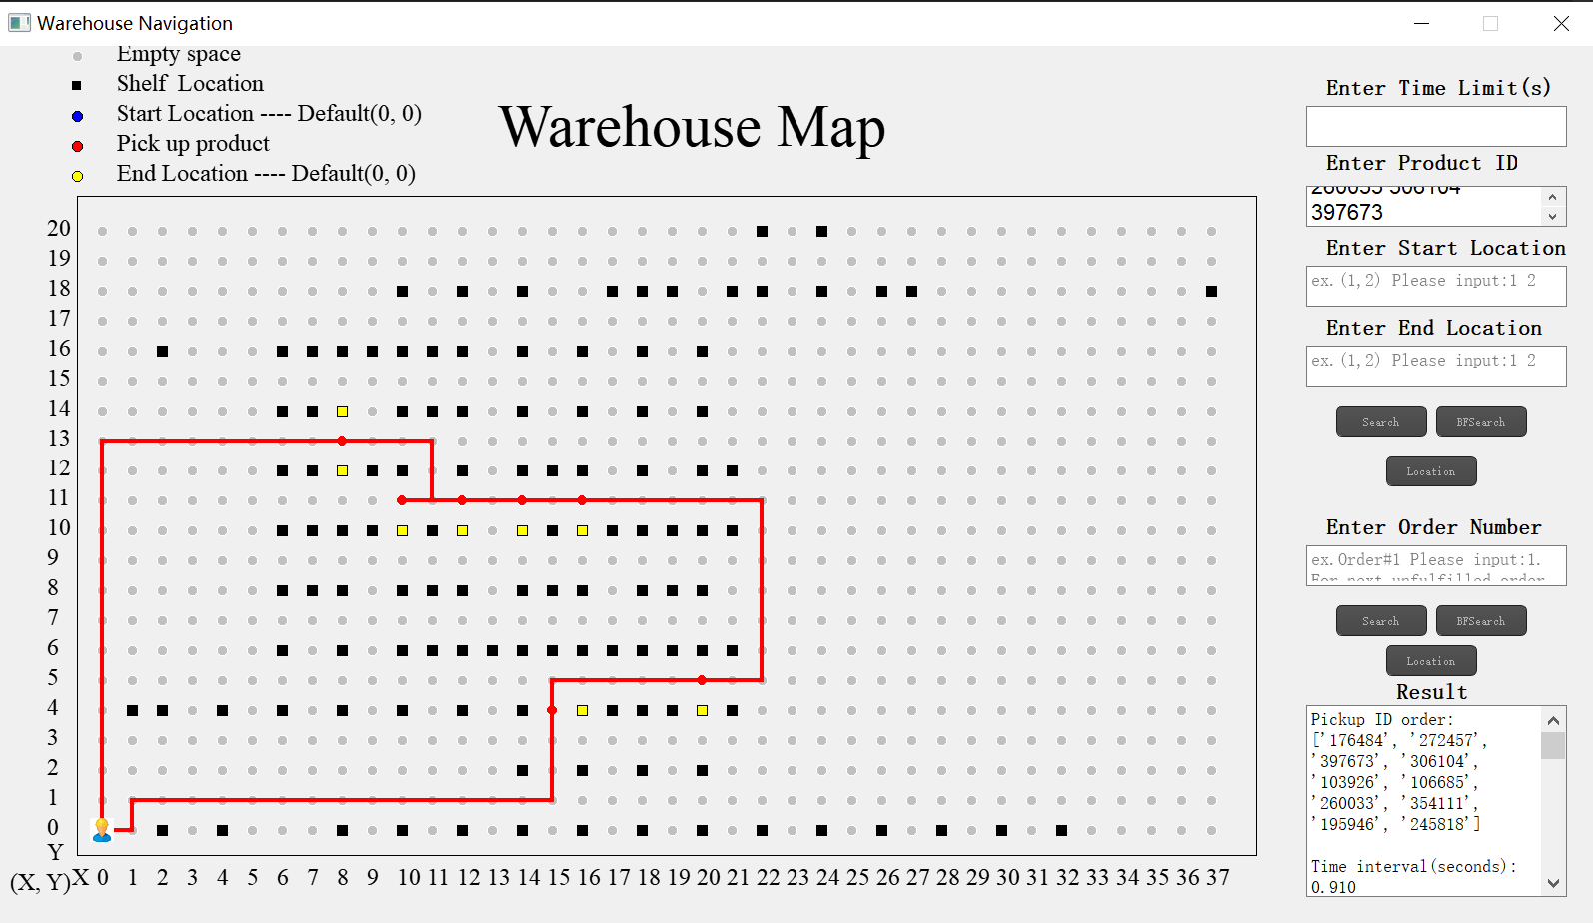
Figure 16 Path of Size 10 Test case 3 by Nearest Neighbours

Directions:
From(0, 0)to(1, 0), then go up
From(1, 0)to(1, 1), then go right
From(1, 1)to(15, 1), then go up
From(15, 1)to(15, 4), then stop
Pick up product(176484)
From(15, 4)to(15, 5), then go right
From(15, 5)to(20, 5), then stop
Pick up product(272457)
From(20, 5)to(22, 5), then go up
From(22, 5)to(22, 11), then go left
From(22, 11)to(16, 11), then stop
Pick up product(397673)
From(16, 11)to(14, 11), then stop
Pick up product(306104)
From(14, 11)to(12, 11), then stop
Pick up product(103926)
Pick up product(106685)
Pick up product(260033)
From(12, 11)to(10, 11), then stop
Pick up product(354111)
From(10, 11)to(11, 11), then go up
From(11, 11)to(11, 13), then go left
From(11, 13)to(8, 13), then stop
Pick up product(195946)
Pick up product(245818)
From(8, 13)to(0, 13), then go down
From(0, 13)to(0, 0), then stop

Size 15 Test case 1(Nearest Neighbours):
ID input order:427230 372539 396879 391680 208660 105912 332555 227534 68048 188856 736830 736831 479020 103313 1
Final pIckup order: 1 208660 427230 372539 396879 391680 188856 68048 736830 736831 479020 105912 332555 227534 103313
Path length: 52
Time interval(s): 1.122
Memory usage(mb):0.004

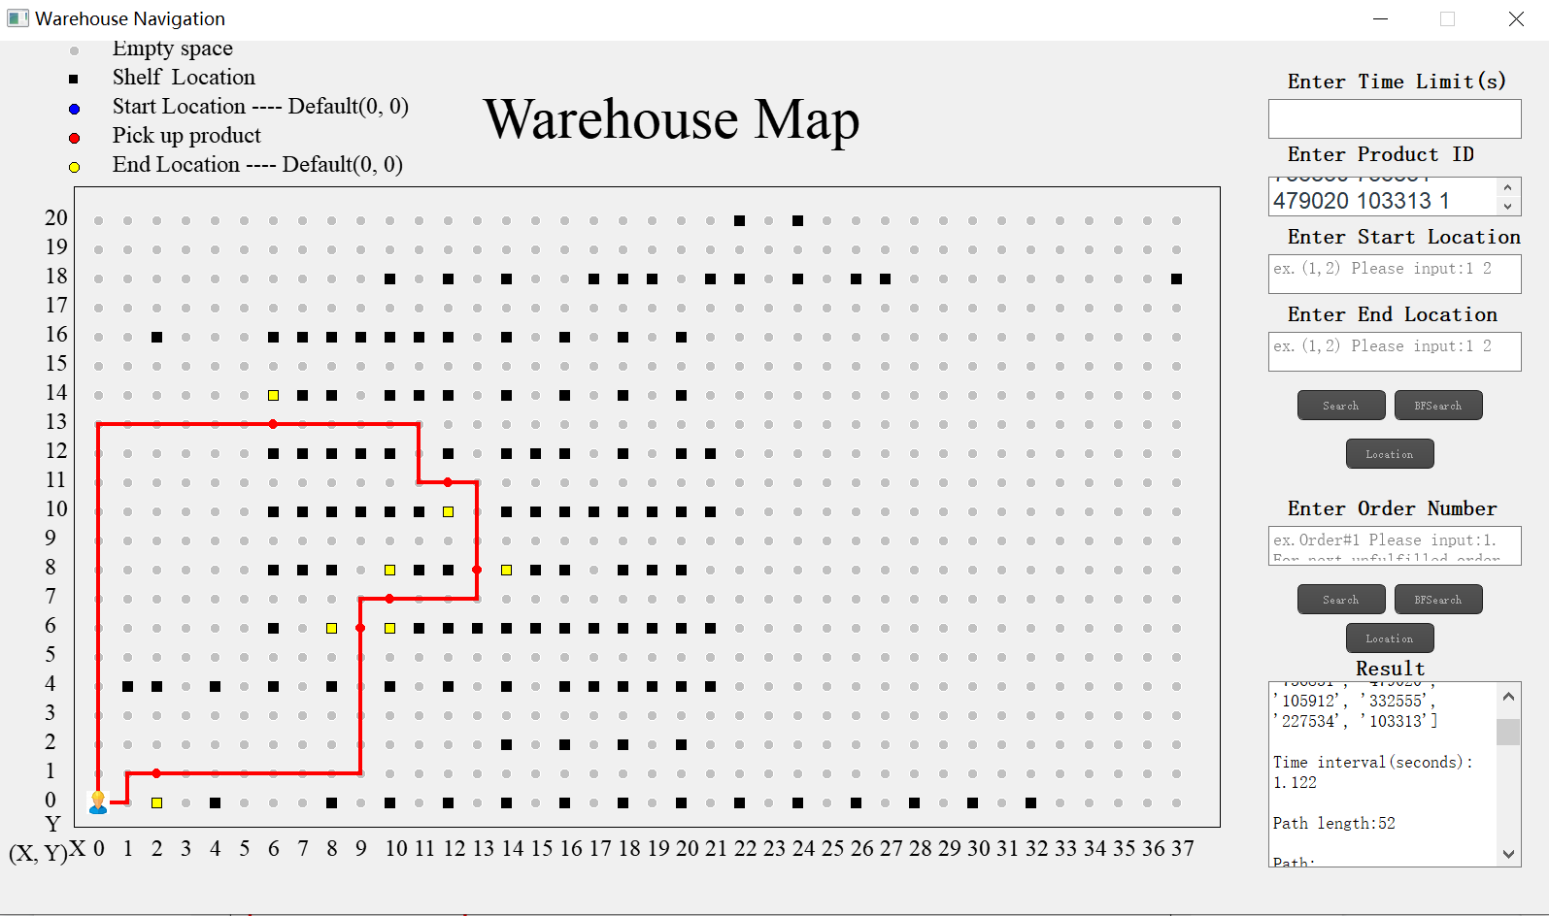
Figure 17 Path of Size 15 Test case 1 by Nearest Neighbours

Directions:
Path:
From(0, 0)to(1, 0), then go up
From(1, 0)to(1, 1), then go right
From(1, 1)to(2, 1), then stop
Pick up product(1)
From(2, 1)to(7, 1), then go up
From(7, 1)to(7, 7), then go right
From(7, 7)to(8, 7), then stop
Pick up product(208660)
From(8, 7)to(10, 7), then stop
Pick up product(427230)
Pick up product(372539)
Pick up product(396879)
Pick up product(391680)
Pick up product(188856)
From(10, 7)to(13, 7), then go up
From(13, 7)to(13, 9), then go right
From(13, 9)to(14, 9), then stop
Pick up product(68048)
Pick up product(736830)
Pick up product(736831)
From(14, 9)to(13, 9), then go up
From(13, 9)to(13, 11), then go left
From(13, 11)to(12, 11), then stop
Pick up product(479020)
From(12, 11)to(11, 11), then go up
From(11, 11)to(11, 13), then go left
From(11, 13)to(9, 13), then go up
From(9, 13)to(9, 15), then go left
From(9, 15)to(6, 15), then stop
Pick up product(105912)
Pick up product(332555)
Pick up product(227534)
Pick up product(103313)
From(6, 15)to(0, 15), then go down
From(0, 15)to(0, 0), then stop

Size 15 Test case 2(Nearest Neighbour):
ID input order:922 977 995 1019 1025 1033 1045 1053 1137 1138 1196 1210 1236 1253 1254
Final pIckup order: 977 1025 1138 1254 1196 1210 1137 922 1236 1053 1045 1033 1019 1253 995
Time interval(s): 1.496
Path length: 98
Memory usage(mb):0.0078
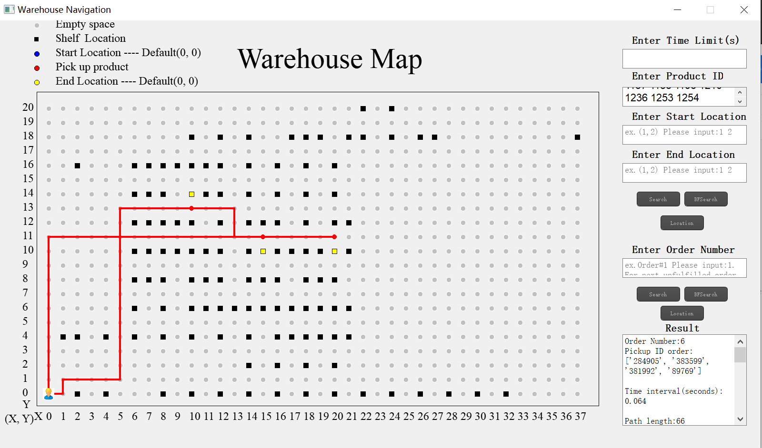
Figure 18 Path of Size 15 Test case 2 by Nearest Neighbours

Directions:
From(0, 0)to(1, 0), then go up
From(1, 0)to(1, 1), then go right
From(1, 1)to(2, 1), then stop
Pick up product(977)
From(2, 1)to(5, 1), then go up
From(5, 1)to(5, 7), then go right
From(5, 7)to(6, 7), then stop
Pick up product(1025)
From(6, 7)to(8, 7), then stop
Pick up product(1138)
From(8, 7)to(9, 7), then go up
From(9, 7)to(9, 9), then go left
From(9, 9)to(8, 9), then stop
Pick up product(1254)
From(8, 9)to(5, 9), then go up
From(5, 9)to(5, 11), then go right
From(5, 11)to(8, 11), then stop
Pick up product(1196)
Pick up product(1210)
From(8, 11)to(10, 11), then stop
Pick up product(1137)
From(10, 11)to(13, 11), then go down
From(13, 11)to(13, 7), then go left
From(13, 7)to(10, 7), then stop
Pick up product(922)
From(10, 7)to(14, 7), then stop
Pick up product(1236)
From(14, 7)to(16, 7), then stop
Pick up product(1053)
From(16, 7)to(18, 7), then stop
Pick up product(1045)
From(18, 7)to(21, 7), then go up
From(21, 7)to(21, 9), then go left
From(21, 9)to(20, 9), then stop
Pick up product(1033)
From(20, 9)to(22, 9), then go up
From(22, 9)to(22, 11), then go left
From(22, 11)to(16, 11), then stop
Pick up product(1019)
From(16, 11)to(14, 11), then stop
Pick up product(1253)
From(14, 11)to(13, 11), then go down
From(13, 11)to(13, 9), then go left
From(13, 9)to(9, 9), then go down
From(9, 9)to(9, 5), then go right
From(9, 5)to(13, 5), then go down
From(13, 5)to(13, 2), then stop
Pick up product(995)
From(13, 2)to(0, 2), then go down
From(0, 2)to(0, 0), then stop

Size 15 Test case 3(Nearest Neighbour):
ID input order:1451 1452 1466 1469 1479 1500 1518 1519 1520 1561 1578 1582 1651 1683 1738
Final pIckup order: 1518 1452 1479 1466 1500 1561 1651 1469 1451 1520 1578 1519 1582 1738 1683
Time interval(s): 1.461
Path length: 110
Memory usage(mb):0.0625
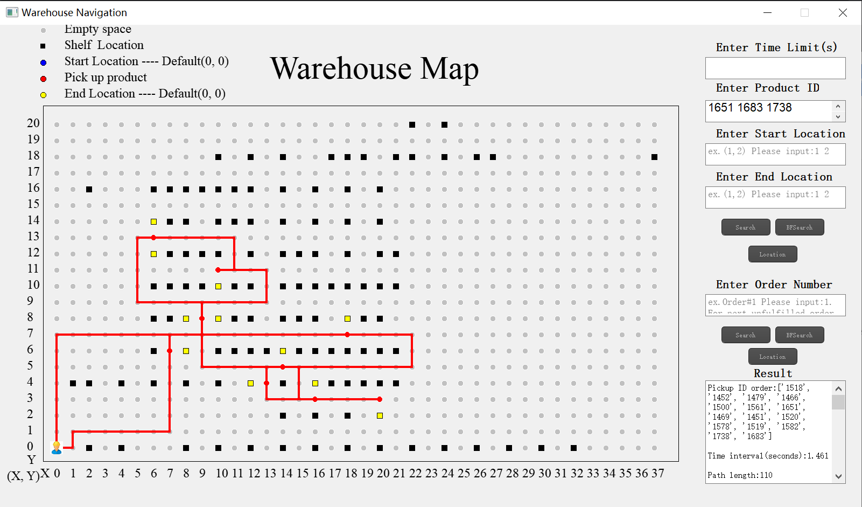
Figure 19 Path of Size 15 Test case 3 by Nearest Neighbours

Directions:
From(0, 0)to(1, 0), then go up
From(1, 0)to(1, 1), then go right
From(1, 1)to(7, 1), then go up
From(7, 1)to(7, 6), then stop
Pick up product(1518)
From(7, 6)to(7, 7), then go right
From(7, 7)to(9, 7), then go up
From(9, 7)to(9, 8), then stop
Pick up product(1452)
Pick up product(1479)
Pick up product(1466)
Pick up product(1500)
Pick up product(1561)
Pick up product(1651)
From(9, 8)to(9, 9), then go right
From(9, 9)to(13, 9), then go up
From(13, 9)to(13, 11), then go left
From(13, 11)to(10, 11), then stop
Pick up product(1469)
From(10, 11)to(11, 11), then go up
From(11, 11)to(11, 13), then go left
From(11, 13)to(6, 13), then stop
Pick up product(1451)
Pick up product(1520)
From(6, 13)to(5, 13), then go down
From(5, 13)to(5, 9), then go right
From(5, 9)to(9, 9), then go down
From(9, 9)to(9, 5), then go right
From(9, 5)to(14, 5), then stop
Pick up product(1578)
From(14, 5)to(15, 5), then go down
From(15, 5)to(15, 3), then go right
From(15, 3)to(16, 3), then stop
Pick up product(1519)
From(16, 3)to(20, 3), then stop
Pick up product(1582)
From(20, 3)to(13, 3), then go up
From(13, 3)to(13, 4), then stop
Pick up product(1738)
From(13, 4)to(13, 5), then go right
From(13, 5)to(22, 5), then go up
From(22, 5)to(22, 7), then go left
From(22, 7)to(18, 7), then stop
Pick up product(1683)
From(18, 7)to(0, 7), then go down
From(0, 7)to(0, 0), then stop

Size 20 Test case 1(Nearest Neighbour):
ID input order:633 1321 3401 5329 10438 372539 396879 16880 208660 105912 332555 227534 68048 188856 736830 736831 479020 103313 1 20373
Final pIckup order: 1 10438 16880 208660 372539 396879 188856 20373 479020 68048 736830 736831 633 3401 5329 105912 332555 227534 103313 1321
Path length: 92
Time interval(s): 2.859
Memory usage(mb):0.1133
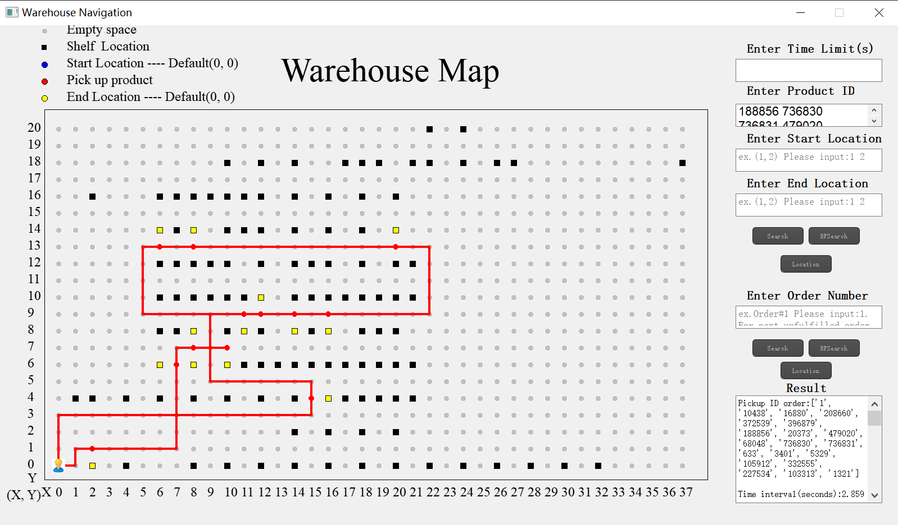
Figure 20 Path of Size 20 Test case 1 by Nearest Neighbours

Directions:
From(0, 0)to(1, 0), then go up
From(1, 0)to(1, 1), then go right
From(1, 1)to(2, 1), then stop
Pick up product(1)
From(2, 1)to(7, 1), then go up
From(7, 1)to(7, 6), then stop
Pick up product(10438)
From(7, 6)to(7, 7), then go right
From(7, 7)to(8, 7), then stop
Pick up product(16880)
Pick up product(208660)
From(8, 7)to(10, 7), then stop
Pick up product(372539)
Pick up product(396879)
Pick up product(188856)
From(10, 7)to(9, 7), then go up
From(9, 7)to(9, 9), then go right
From(9, 9)to(11, 9), then stop
Pick up product(20373)
From(11, 9)to(12, 9), then stop
Pick up product(479020)
From(12, 9)to(14, 9), then stop
Pick up product(68048)
Pick up product(736830)
Pick up product(736831)
From(14, 9)to(16, 9), then stop
Pick up product(633)
From(16, 9)to(22, 9), then go up
From(22, 9)to(22, 13), then go left
From(22, 13)to(20, 13), then stop
Pick up product(3401)
From(20, 13)to(8, 13), then stop
Pick up product(5329)
From(8, 13)to(6, 13), then stop
Pick up product(105912)
Pick up product(332555)
Pick up product(227534)
Pick up product(103313)
From(6, 13)to(5, 13), then go down
From(5, 13)to(5, 9), then go right
From(5, 9)to(9, 9), then go down
From(9, 9)to(9, 5), then go right
From(9, 5)to(15, 5), then go down
From(15, 5)to(15, 4), then stop
Pick up product(1321)
From(15, 4)to(15, 3), then go left
From(15, 3)to(0, 3), then go down
From(0, 3)to(0, 0), then stop

Size 20 Test case 2(Nearest Neighbour):
ID input order:3293 3296 3315 3317 3326 3352 3353 3358 3401 3504 3547 3564 3568 3611 3632 3716 3721 3726 3749 3764
Final pIckup order: 3358 3353 3315 3317 3611 3504 3568 3632 3749 3326 3764 3401 3293 3296 3721 3547 3564 3726 3352 3716
Time interval(s): 2.714
Path length: 92
Memory usage(mb):0.0625
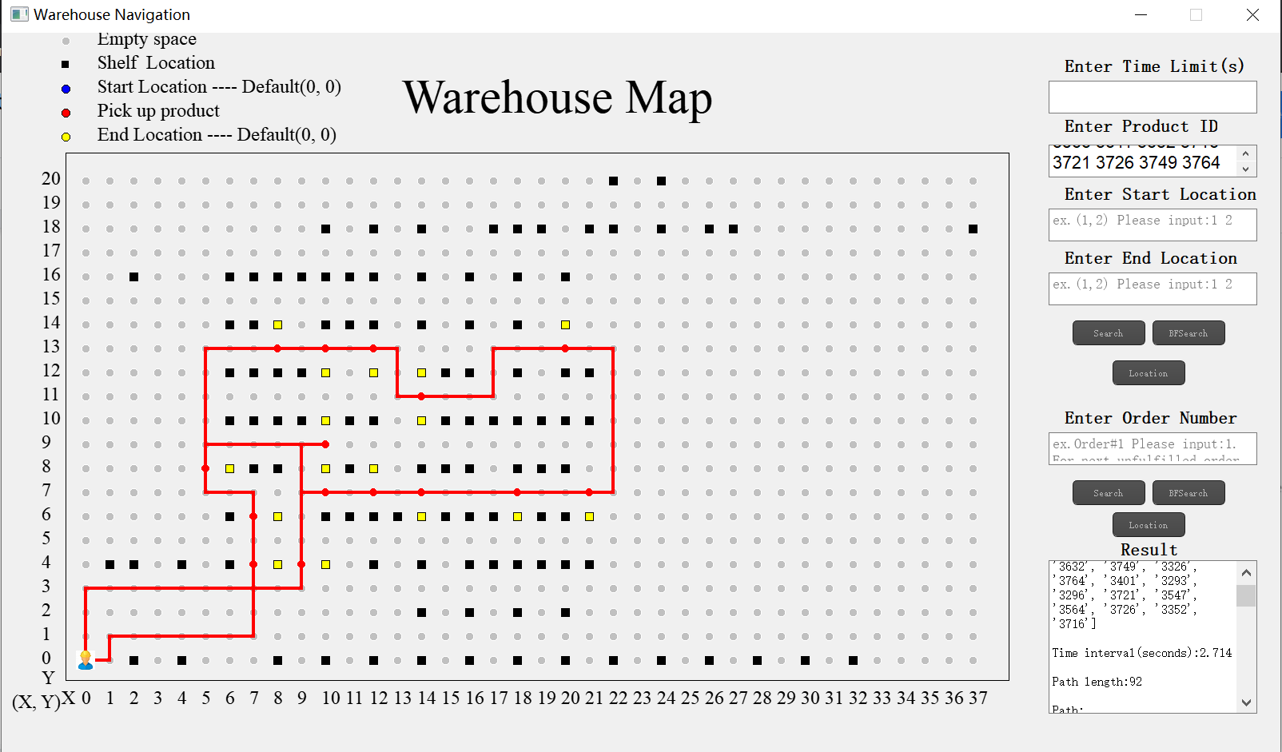
Figure 21 Path of Size 20 Test case 2 by Nearest Neighbours

Directions:
From(0, 0)to(1, 0), then go up
From(1, 0)to(1, 1), then go right
From(1, 1)to(7, 1), then go up
From(7, 1)to(7, 4), then stop
Pick up product(3358)
From(7, 4)to(7, 6), then stop
Pick up product(3353)
From(7, 6)to(7, 7), then go left
From(7, 7)to(5, 7), then go up
From(5, 7)to(5, 8), then stop
Pick up product(3315)
From(5, 8)to(5, 9), then go right
From(5, 9)to(10, 9), then stop
Pick up product(3317)
From(10, 9)to(9, 9), then go down
From(9, 9)to(9, 7), then go right
From(9, 7)to(10, 7), then stop
Pick up product(3611)
From(10, 7)to(12, 7), then stop
Pick up product(3504)
Pick up product(3568)
From(12, 7)to(14, 7), then stop
Pick up product(3632)
Pick up product(3749)
From(14, 7)to(18, 7), then stop
Pick up product(3326)
From(18, 7)to(21, 7), then stop
Pick up product(3764)
From(21, 7)to(22, 7), then go up
From(22, 7)to(22, 13), then go left
From(22, 13)to(20, 13), then stop
Pick up product(3401)
From(20, 13)to(17, 13), then go down
From(17, 13)to(17, 11), then go left
From(17, 11)to(14, 11), then stop
Pick up product(3293)
Pick up product(3296)
Pick up product(3721)
From(14, 11)to(13, 11), then go up
From(13, 11)to(13, 13), then go left
From(13, 13)to(12, 13), then stop
Pick up product(3547)
Pick up product(3564)
From(12, 13)to(10, 13), then stop
Pick up product(3726)
From(10, 13)to(8, 13), then stop
Pick up product(3352)
From(8, 13)to(5, 13), then go down
From(5, 13)to(5, 9), then go right
From(5, 9)to(9, 9), then go down
From(9, 9)to(9, 4), then stop
Pick up product(3716)
From(9, 4)to(9, 3), then go left
From(9, 3)to(0, 3), then go down
From(0, 3)to(0, 0), then stop

Size 20 Test case 3(Nearest Neighbour):
ID input order:3900 3922 3967 3979 3992 4016 4063 4086 4103 4107 4167 4197 4211 4240 4258 4275 4319 4362 4365 4369
Final pIckup order: 4167 3922 3967 4211 4365 4063 4086 4107 4319 4240 4258 4362 4275 3992 4103 4197 4016 3979 4369 3900
Time interval(s): 4.465
Path length: 156
Memory usage(mb):0.0859
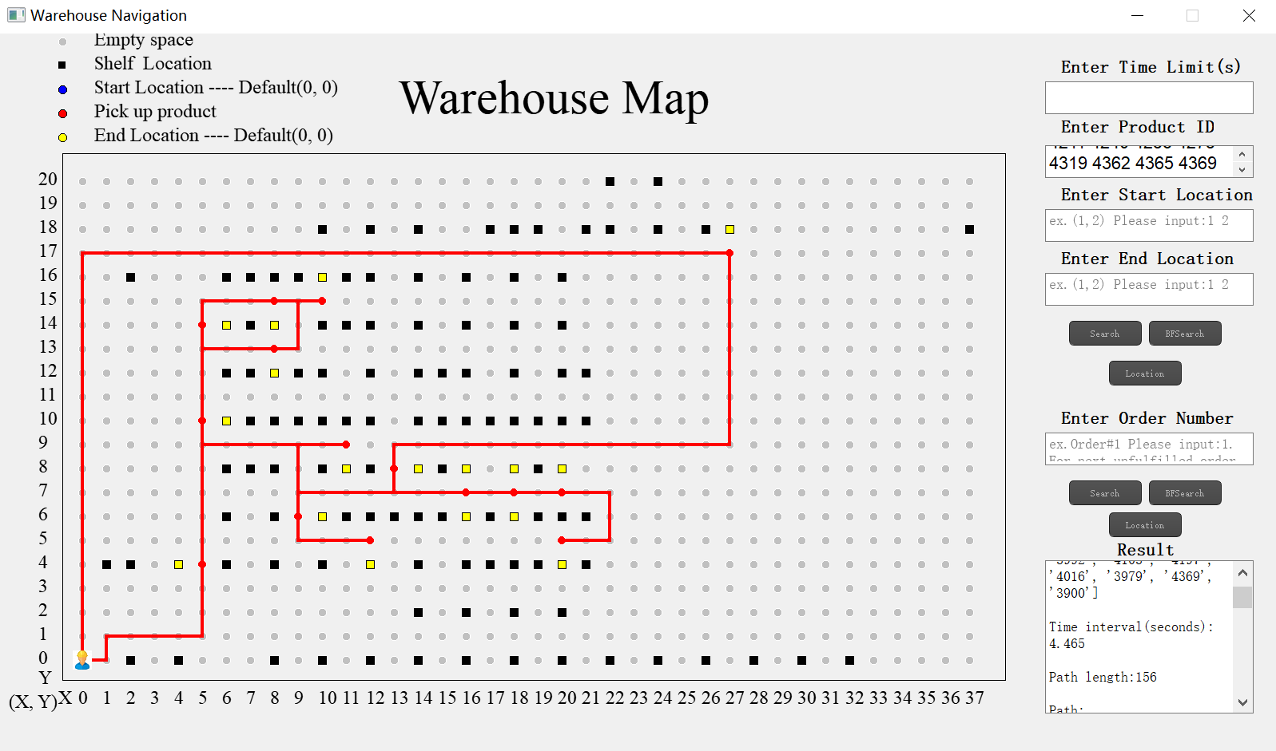
Figure 22 Path of Size 20 Test case 3 by Nearest Neighbours

Directions:
From(0, 0)to(1, 0), then go up
From(1, 0)to(1, 1), then go right
From(1, 1)to(5, 1), then go up
From(5, 1)to(5, 4), then stop
Pick up product(4167)
From(5, 4)to(5, 10), then stop
Pick up product(3922)
Pick up product(3967)
Pick up product(4211)
From(5, 10)to(5, 13), then go right
From(5, 13)to(8, 13), then stop
Pick up product(4365)
From(8, 13)to(9, 13), then go up
From(9, 13)to(9, 15), then go left
From(9, 15)to(8, 15), then stop
Pick up product(4063)
From(8, 15)to(10, 15), then stop
Pick up product(4086)
From(10, 15)to(5, 15), then go down
From(5, 15)to(5, 14), then stop
Pick up product(4107)
From(5, 14)to(5, 9), then go right
From(5, 9)to(11, 9), then stop
Pick up product(4319)
From(11, 9)to(9, 9), then go down
From(9, 9)to(9, 6), then stop
Pick up product(4240)
From(9, 6)to(9, 5), then go right
From(9, 5)to(12, 5), then stop
Pick up product(4258)
From(12, 5)to(9, 5), then go up
From(9, 5)to(9, 7), then go right
From(9, 7)to(16, 7), then stop
Pick up product(4362)
Pick up product(4275)
From(16, 7)to(18, 7), then stop
Pick up product(3992)
Pick up product(4103)
Pick up product(4197)
From(18, 7)to(20, 7), then stop
Pick up product(4016)
From(20, 7)to(22, 7), then go down
From(22, 7)to(22, 5), then go left
From(22, 5)to(20, 5), then stop
Pick up product(3979)
From(20, 5)to(22, 5), then go up
From(22, 5)to(22, 7), then go left
From(22, 7)to(13, 7), then go up
From(13, 7)to(13, 8), then stop
Pick up product(4369)
From(13, 8)to(13, 9), then go right
From(13, 9)to(27, 9), then go up
From(27, 9)to(27, 17), then stop
Pick up product(3900)
From(27, 17)to(0, 17), then go down
From(0, 17)to(0, 0), then stop

Result Analysis

As can be seen from the above graph and data, in most situations, Nearest Neighbor could provide the same shortest path and best pick-up order compared to Brute Force. However, Brute Force algorithm engages a larger memory usage and longer running time and it can’t handle large size order inputs.

